Experiment 7: Travelling Salesman Problem (TSP)
Aim
To solve the Travelling Salesman Problem using Python.
Objective
To find the minimum cost path that visits every city exactly once.
Algorithm
- Define the distance matrix.
- Generate all possible paths.
- Calculate the cost of each path.
- Find the minimum cost.
- Display the optimal path.
Flowchart
Start
|
Read Distances
|
Generate Paths
|
Find Minimum Cost
|
Display Path
|
Stop
Code
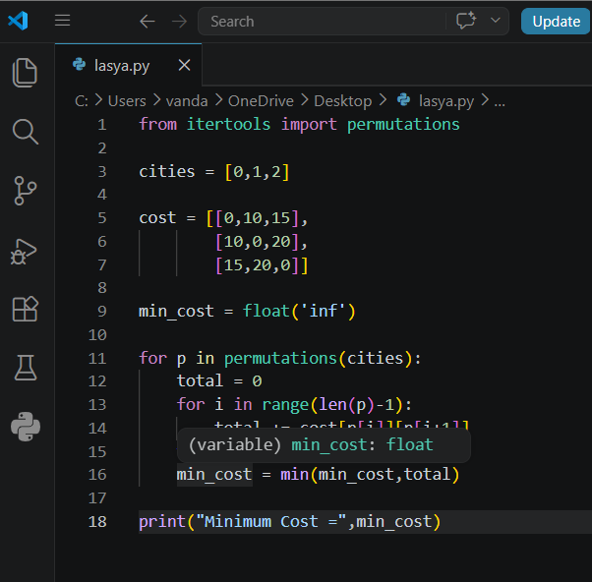
Output:
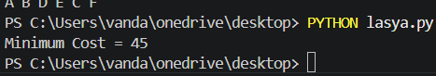
Result
The minimum travelling cost was found successfully.
Conclusion
The program finds the shortest route covering all cities.

